**GOOD MORNING**

**"The more that you read/do, the more things you will know. The more that you learn the more places you'll go."**

**Welcome to My Presentation**

**Pushpala Monika**

**Certified Tosca Professional**

**TOSCA**

**DAY-1:**

**Following are some positive and negative points of Tosca:**

**Positive:**

* **Test management and Automation Tool in one**
* **No Scripting**
* **Testing methodology**
* **Supports the most common technologies (HTML, Java, SOA, SAP, Oracle, …)**
* **Good vendor support**

**Negative:**

* **Not easy to learn and setup efficiently, especially in a large organization**
* **Coding (when necessary) can be complex**
* **Pricing**

**It is a commercial tool, so it should be compared to other commercial tools like HP-Suite. If a freeware tool fits your needs its ok, no need to spend money. TOSCA provides action modes for this (Input, Verify, Buffer), which can be selected from a list for the control. Non-technical testers will prefer this approach to scripting.**

**What I really appreciate with Tricentis is that they not only provide a tool, but also propose a sophisticated testing strategy. The TCD Design (Test Case Design) module can guide you to the minimum number of necessary test cases giving a high coverage. It’s quite easy to review the test design of different testers and to understand their ideas.**

**Tosca Architecture:**

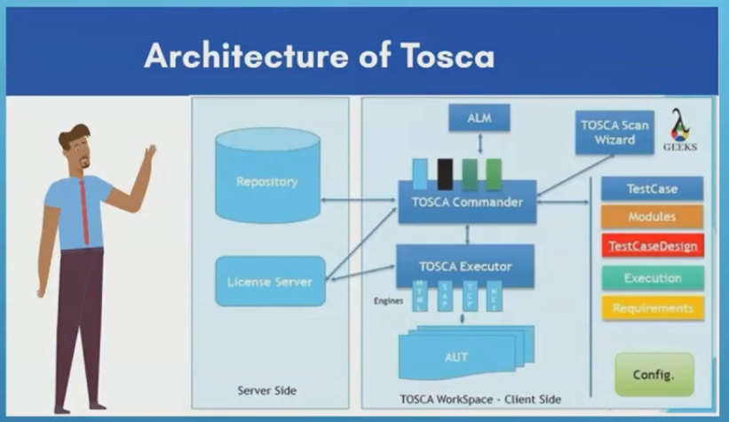

**ALM-Application lifecycle Management**

**The key components on client side are:**

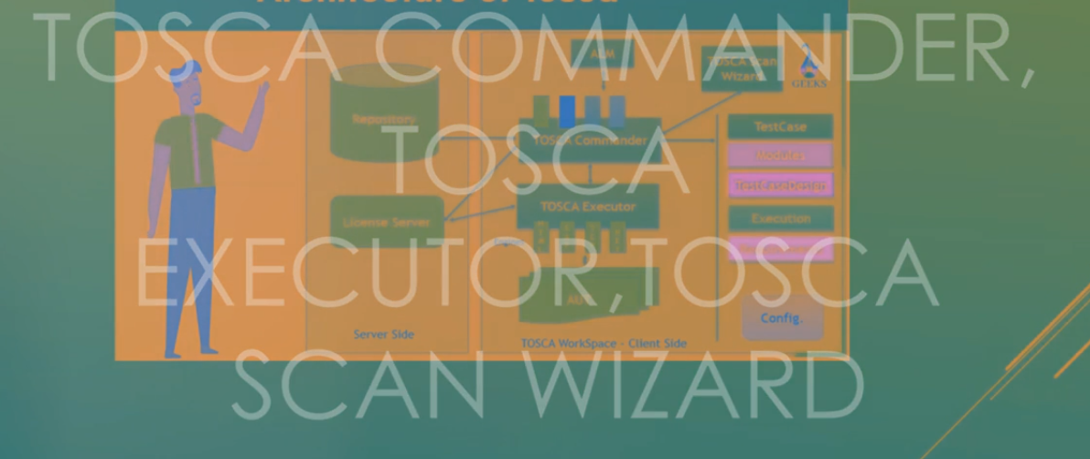

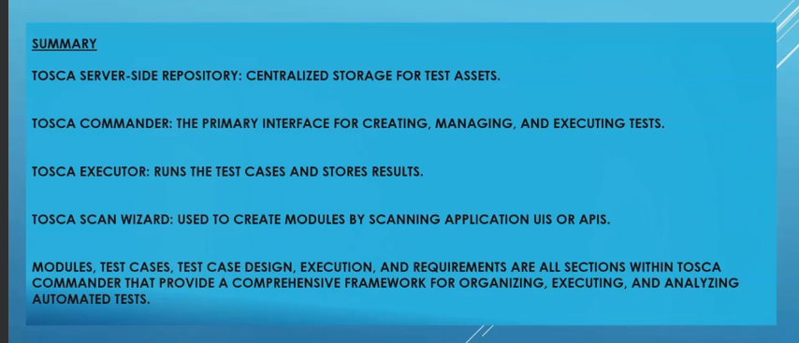

**1) First link--Tricentis Tosca Fundamentals − Automating web application testing (AS1):--**

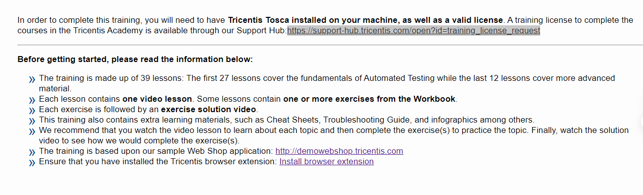

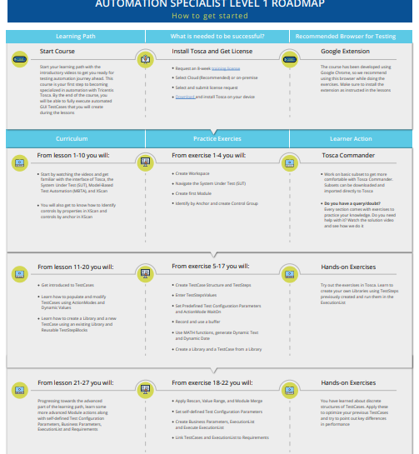

**Description**

**Overview:**

**This Learning Path marks the start of your journey through test automation using Tricentis Tosca. The scope lies on automating testing for simple HTML applications without any coding involved. From exploring Tricentis Tosca's capabilities to practicing the newly gained skills, this Learning Path walks you step by step through the entire testing process of building automated tests quickly and efficiently.**

**Learning Objectives:**

**By the end of this Online Course, you will be able to:**

* **Capture the technical information from your System under Test needed for test automation.**
* **Create automated tasks to perform on your system under test.**
* **Run your first test with Tosca.**
* **Identify testing criteria for your system under test and reflect it in Tosca.**
* **Demonstrate how to enhance test data maintenance and reusability for a more efficient test automation.**

**Prerequisites**

**knowledge: Basic understanding of software testing concepts**

**Technical: Access to and valid license for Tricentis Tosca.**

**product version: This content was developed using Tosca 14.x. You may notice some minor UI differences between your installed version and the learning materials.**

TOSCA INSTALLATION: Please follow the below link to install:

<https://www.tricentis.com/software-testing-tool-trial-demo/tosca-trial>

Then Browser Extension: Use any one preferable Manually--

https://support-hub.tricentis.com/open?id=show_search_result&lang=en&path=%2Ftosca%2F1520%2Fen%2Fcontent%2Fengines_3.0%2Fxbrowser%2Fxbrowser_scan.htm&product=tosca&sessionRotationTrigger=true&type=product_manual&version=16.0

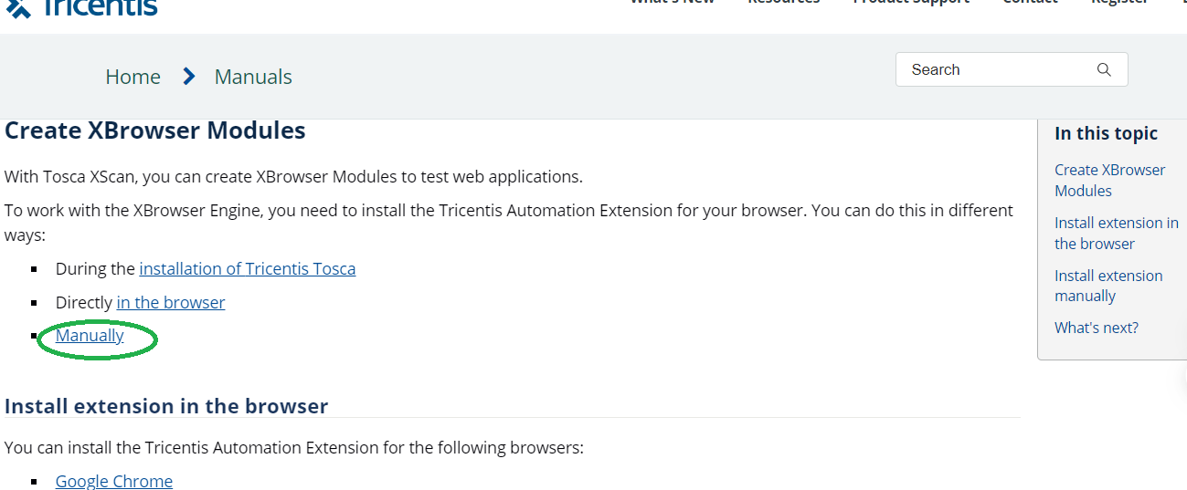

**Section 1:**

INTRODUCTION: lesson 1



[https://mindmajix.com/tosca-tutorial](https://mindmajix.com/tosca-tutorial%20%20%20)

===Contents From this link:

TOSCA Contains 5 Sections:--

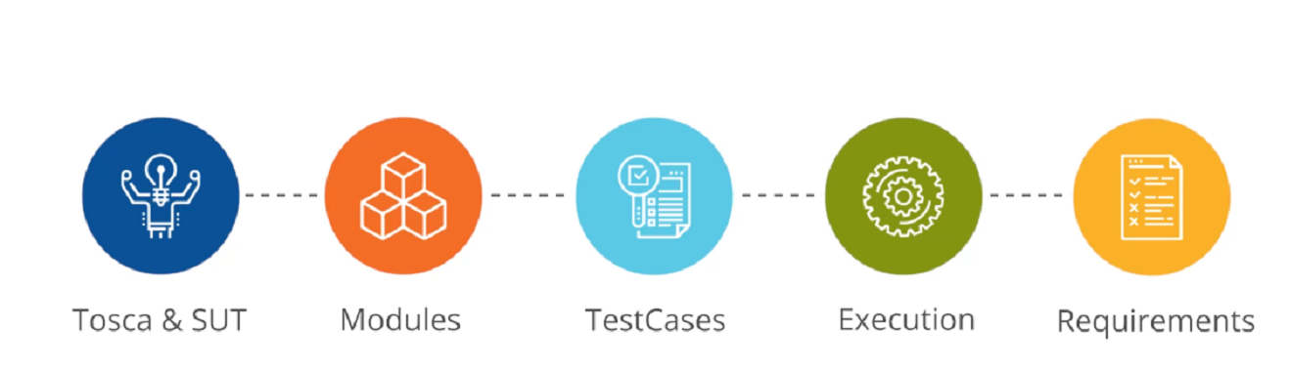

**SUT-->System under TEST**

**Here we are going to see TOSCA &SUT with Demo Web Shop Application:**

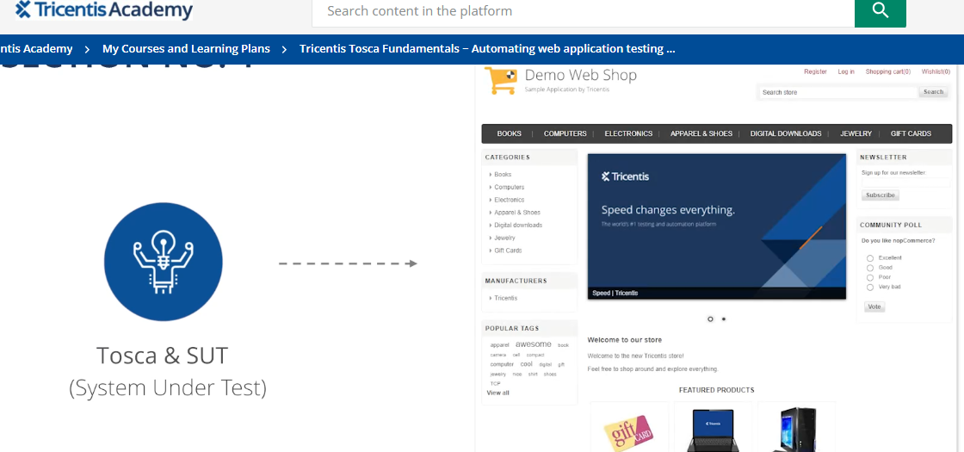

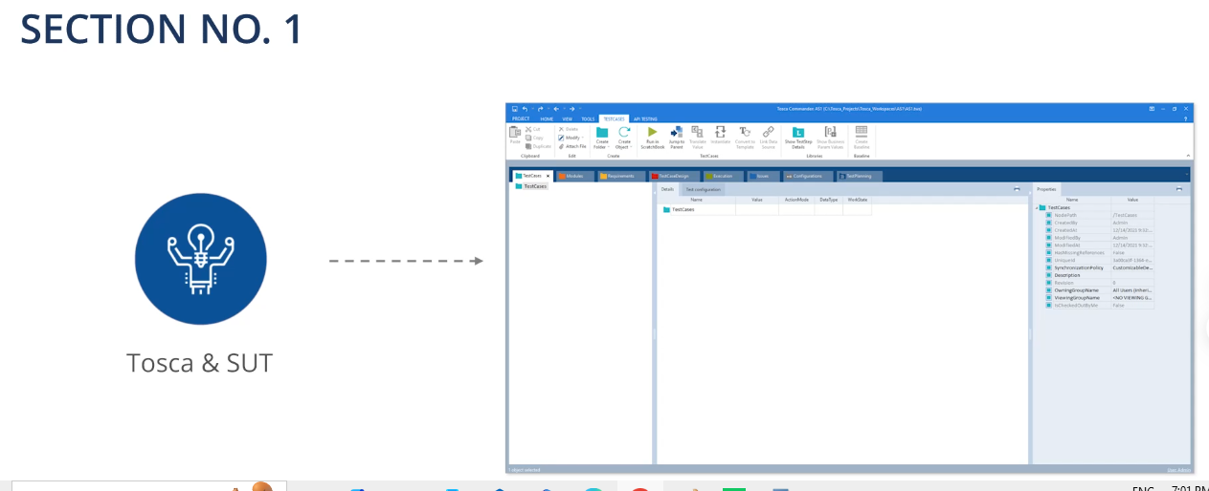

Technical information of SUT by simple scanning it and creating Modules in order to store the Scanned elements in Tosca as it is Code free:

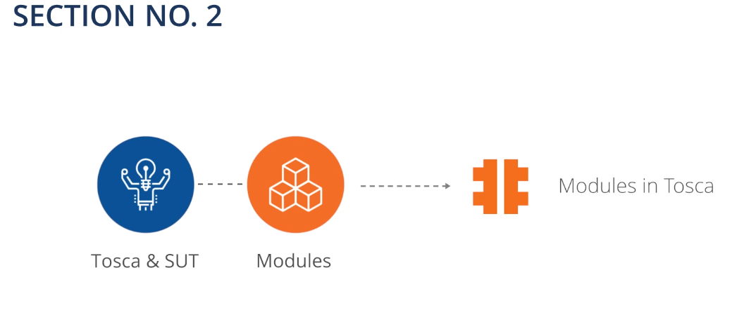

**SECTION NO. 3**

Then we create Test Cases

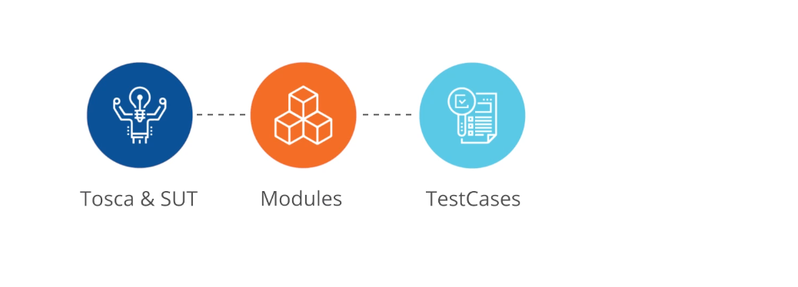

**Test Cases contains:**

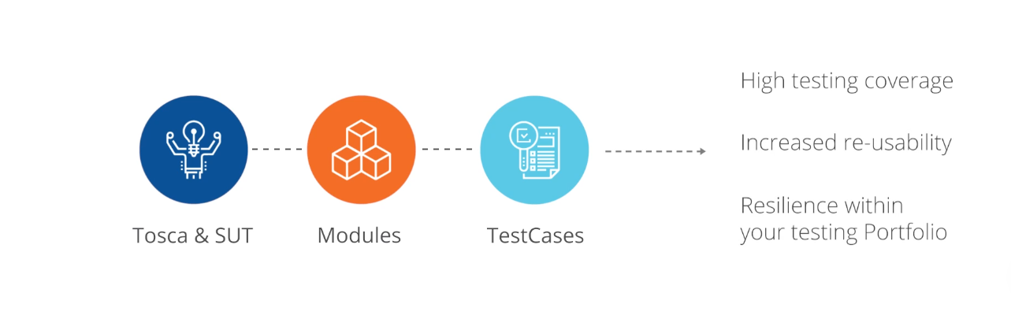

**SECTION NO. 4:**

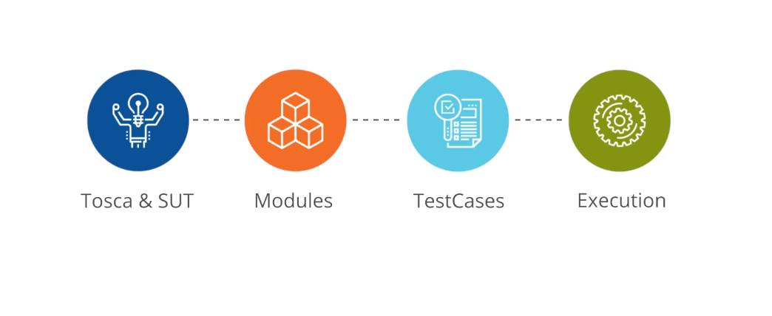

**SECTION NO. 5:**

We need to link the Test back to Requirements at the end:

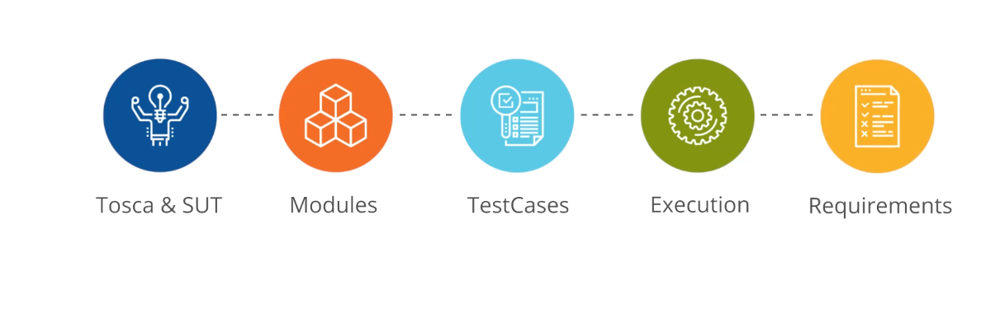

**We AIM for :**

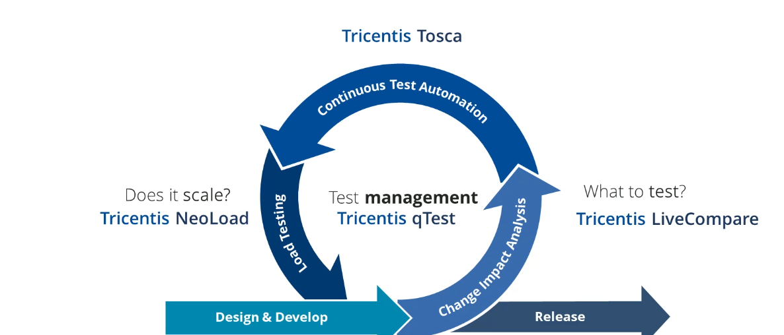

**ABOUT TOSCA :--lesson 2**

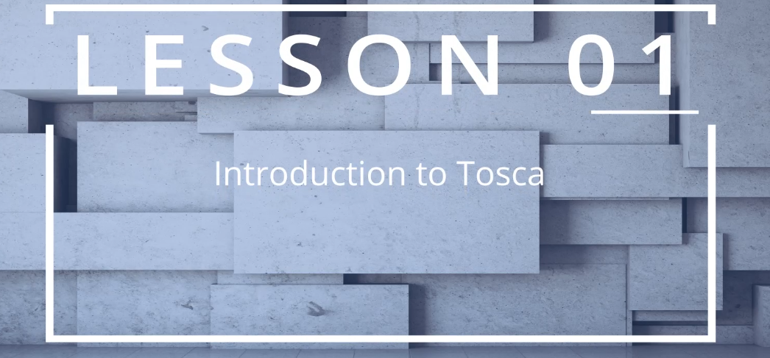

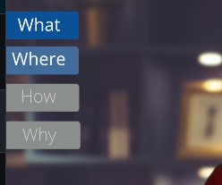

**What, Where, How and Why --Workspace is needed**

**Create a NEW Work SPACE:**

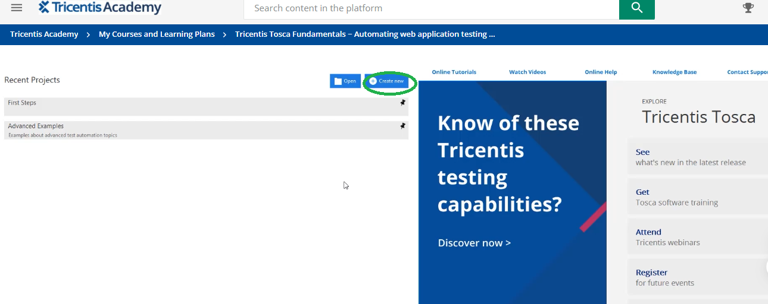

By clicking on Create new we can create work space: Explain each one in detail

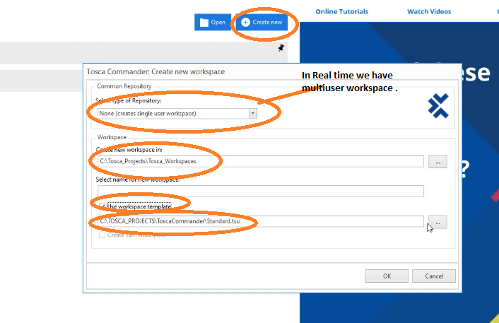

IF it does select this then it would be **BLANK WORKSPACE first ...-->browse and select the one which we downloaded from TOSCA tool:**

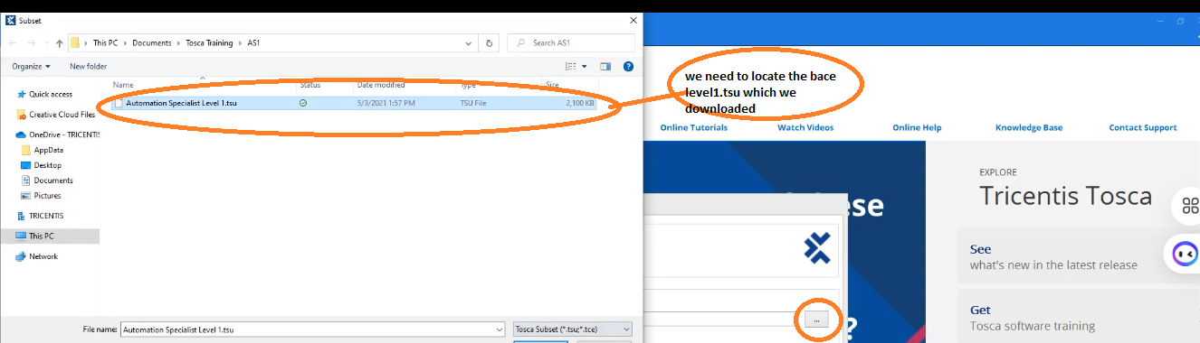

**This “.tsu “file contains the following---Explain**

**Note:**

**1) This is an Example of Demo Web shop.**

**2) Google.com**

**3) Yahoo.com/Gmail—signing and login**

**4) Zoho.com**

**5) Yatra.com**

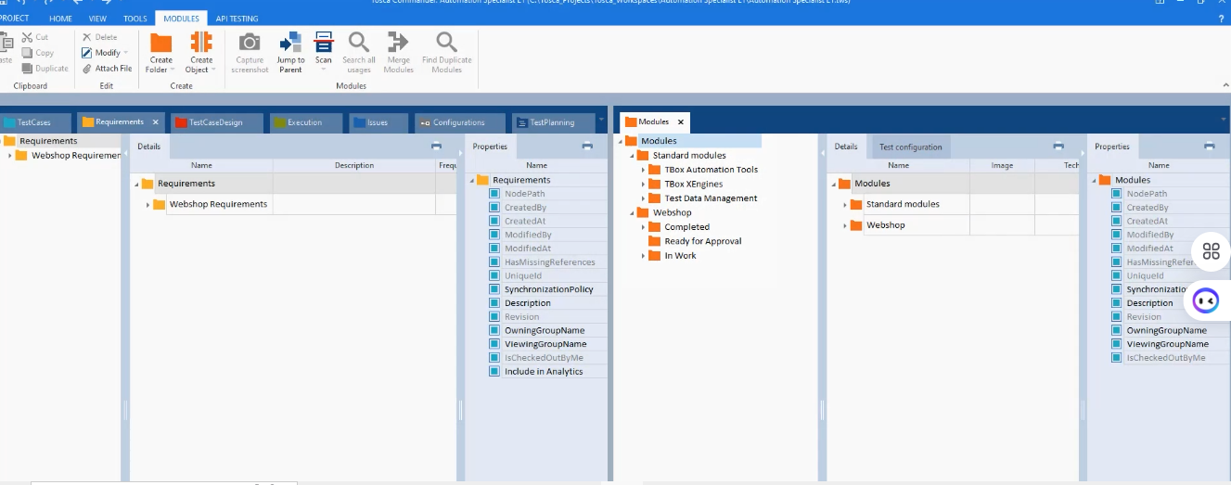

**Workspace can help you to PLAN, CREATE AND EXECUTE YOUR TEST :**

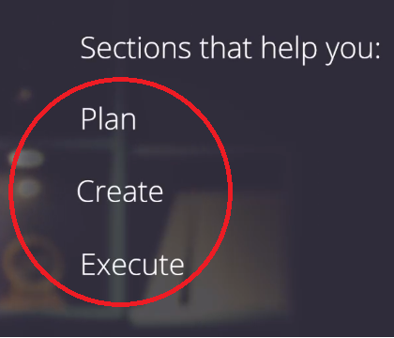

We Talk about Multiuser Workspace:

**Firstly about single user and then multiuser Explain**

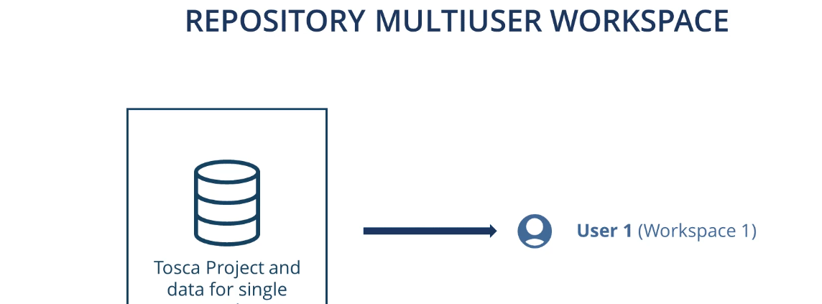

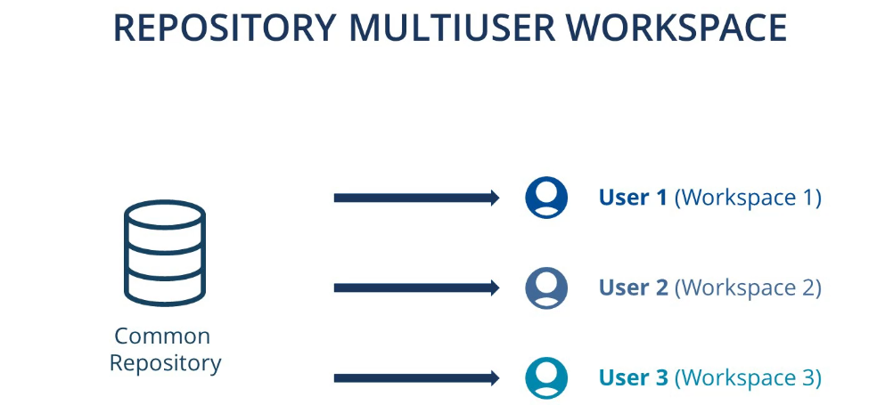

**But how ever TOSCA recommend Single user workspace--Best Practice**

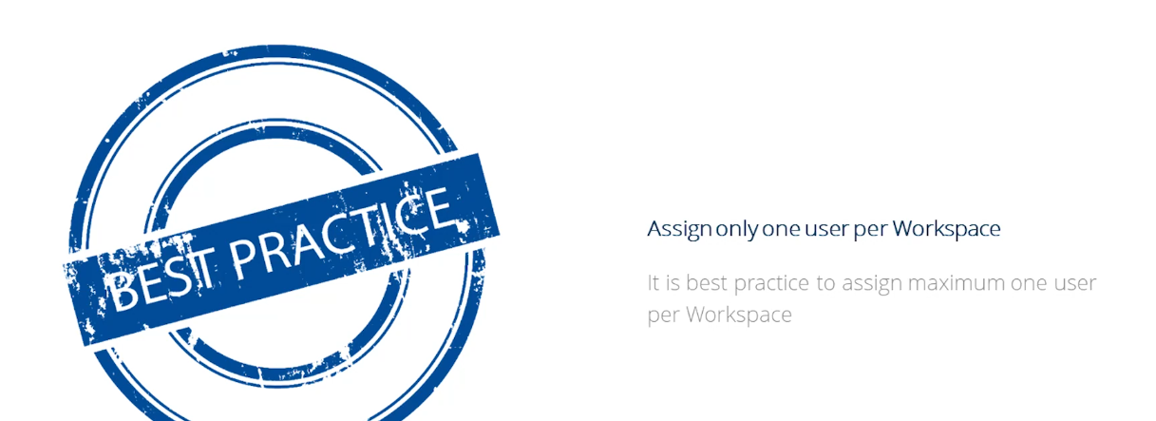

**But however You can Export and Import form Project to Another with the help of SUBSETS:**

**In case you want to transfer some elements form one common Repository to another can be**

**Done easily:**

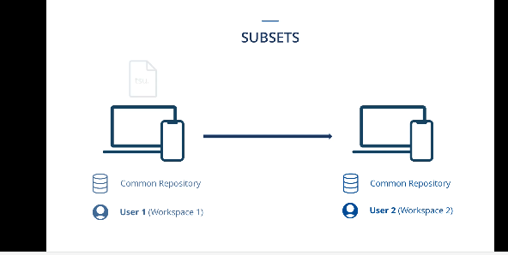

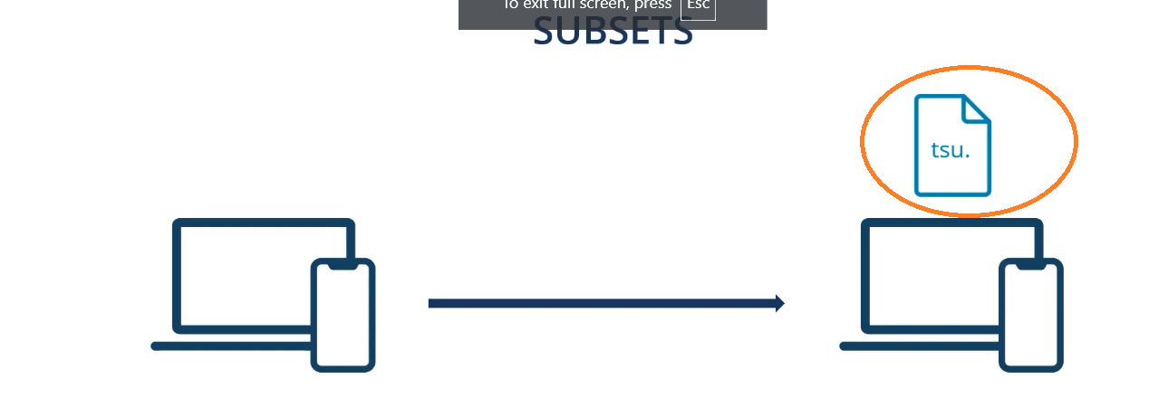

**You can Export the subset by selecting all of them:**

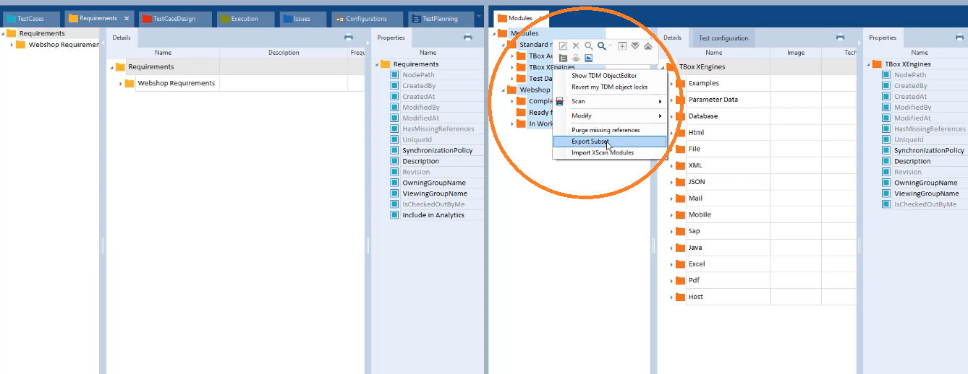

**In case of Import :**

**Hence do the following correctly:**

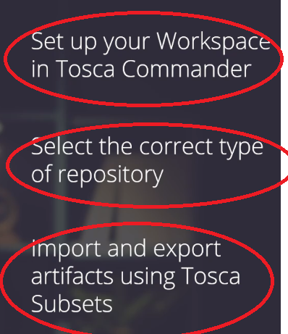

Now we will navigate you to this section:

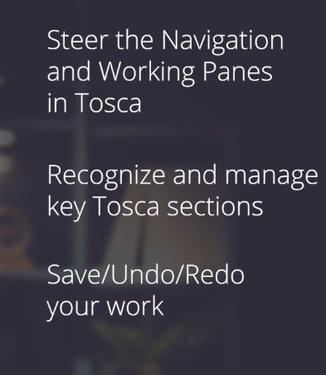

**Now you can add columns by right clicking on column: Choose Column chooser and add as many columns you want and show them how to delete it to by dragging column down and release as shown next image:**

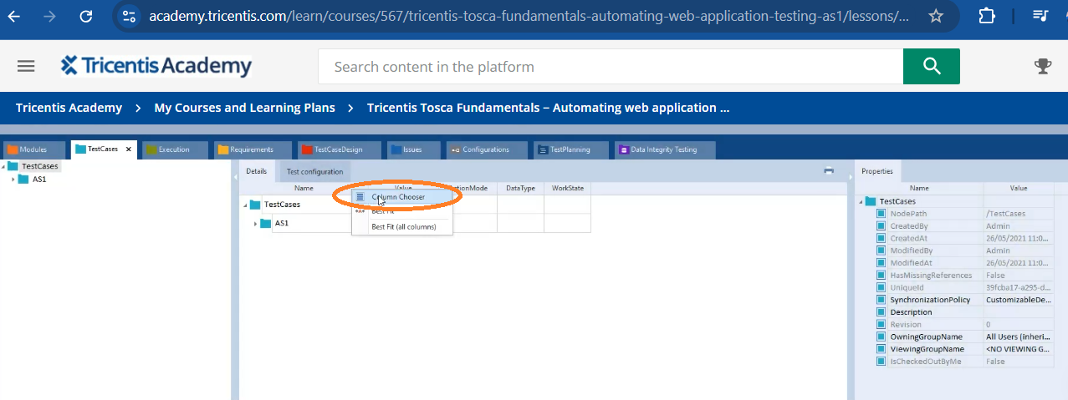

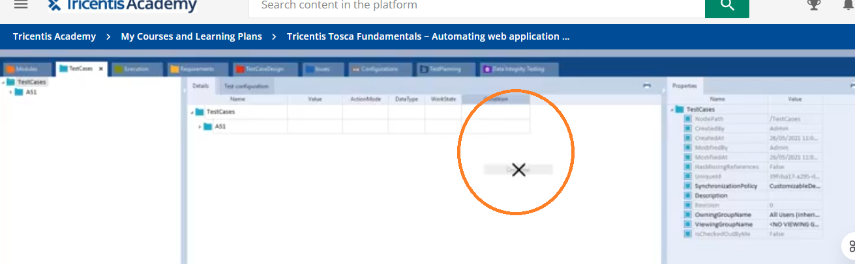

**We have 8/9 different section (Data Integrating Section-older version) of which we will talk on 4 section now:**

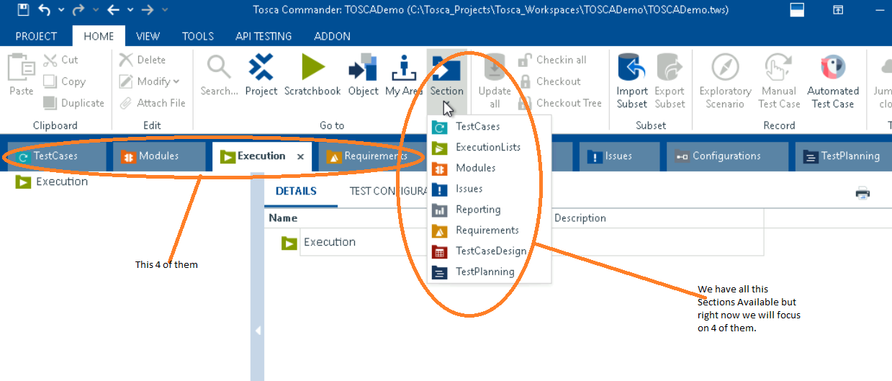

**1)Modules: Show them you can arrange modules as you like ---just drag and release**

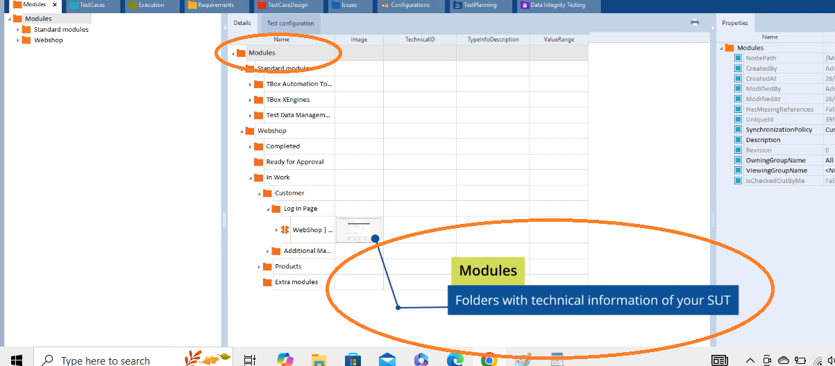

**Modules are Maintain Technical stuff—means It is more like object Repository more advance one compare with some other tool.**

**2)Test cases: Test cases where you manage input values, your business logic, Test data and even the flow of Test case are managed here.**

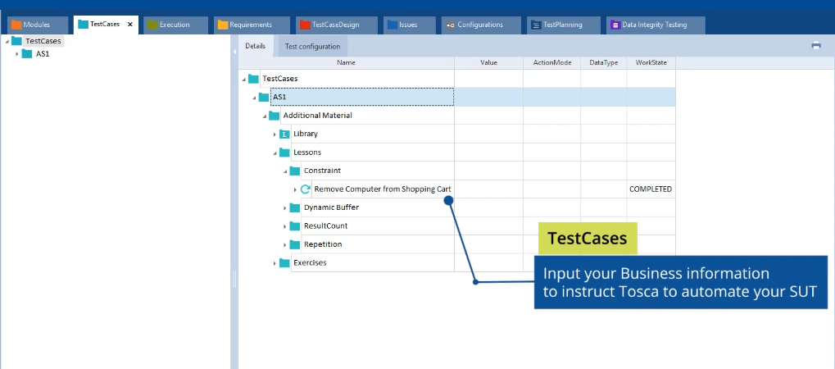

**3)Execution: You can Execute your testcases here.**

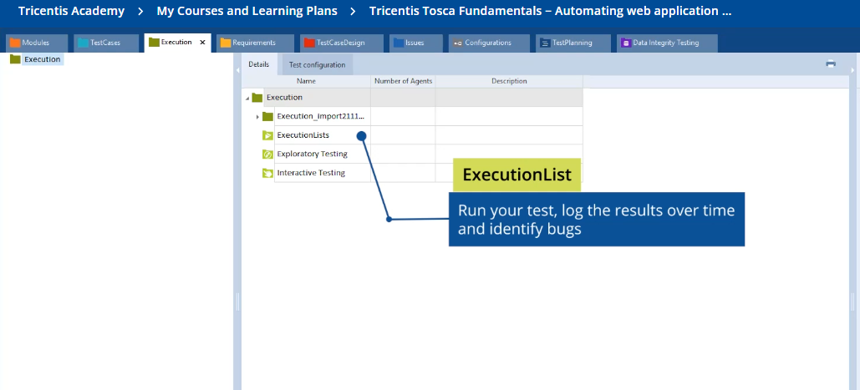

**4)Requirements: Manage your Business Requirements both you Test cases and Execution suites/Sections can me mapped in Requirement section so that it give you the traceability whenever they are Executed. It says what % they are executed etc.**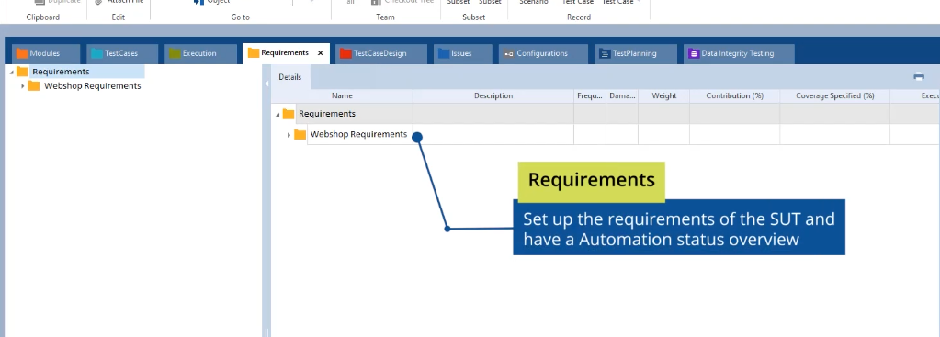

**Now select the Project --Say DEMOPRJ the one To Create thework spaceand then Right click on it and Explain all of them in detail:**

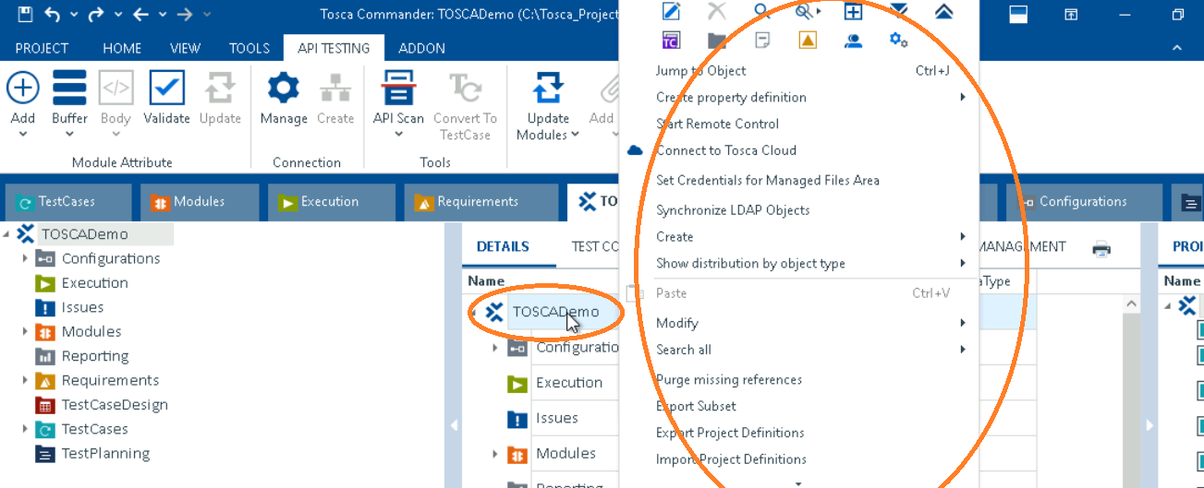

**Explain about undo and redo works only when the project is not saved.**

Tosca Automation Extension in Browser:

1. **As with Tosca Xsan you can create X Browser modules in order to test Web applications.**
2. **In order to work with Browser Engine.**
3. **All Browser are available—Chrome, Edge, Firefox etc.**

**Use the link below to do so:**

**https://support-hub.tricentis.com/open?id=show_search_result&lang=en&path=%2Ftosca%2F1520%2Fen%2Fcontent%2Fengines_3.0%2Fxbrowser%2Fxbrowser_scan.htm&product=tosca&sessionRotationTrigger=true&type=product_manual&version=16.0**

**lesson 3:**

**Best Practice:**

**1)Naming conversation and Description later like for example below:**

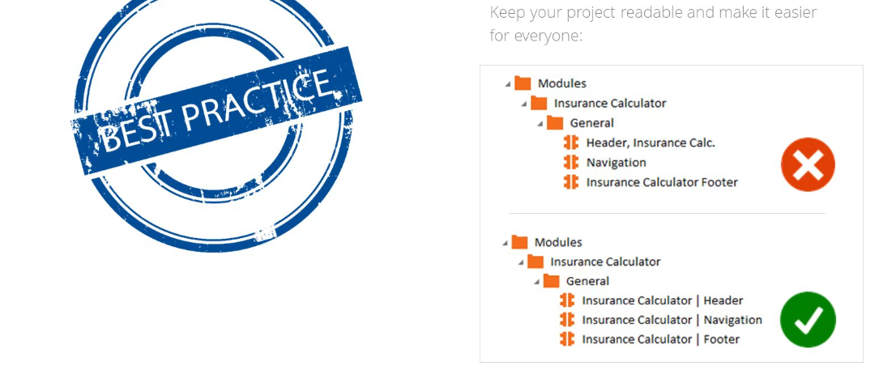

**2) Repository structure which contains Component folder and Section folders under that:**

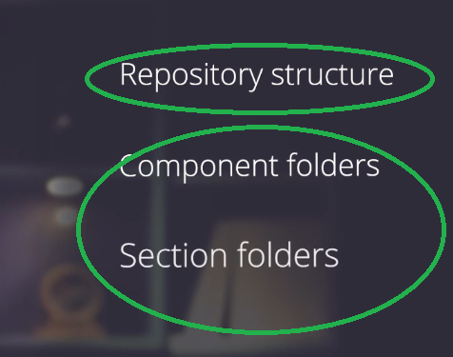

**Like Example:**

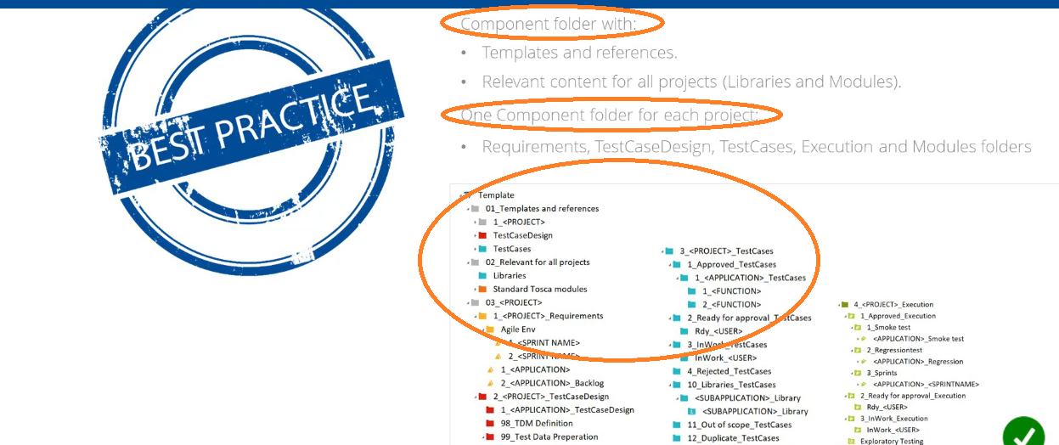

**3)**

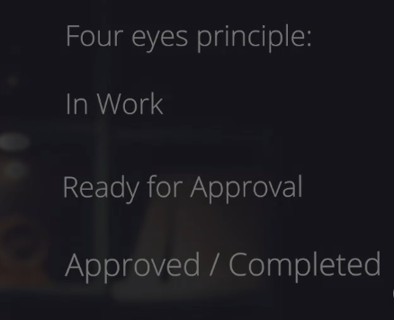**====Explain Ready for Approval and Approval Briefly**

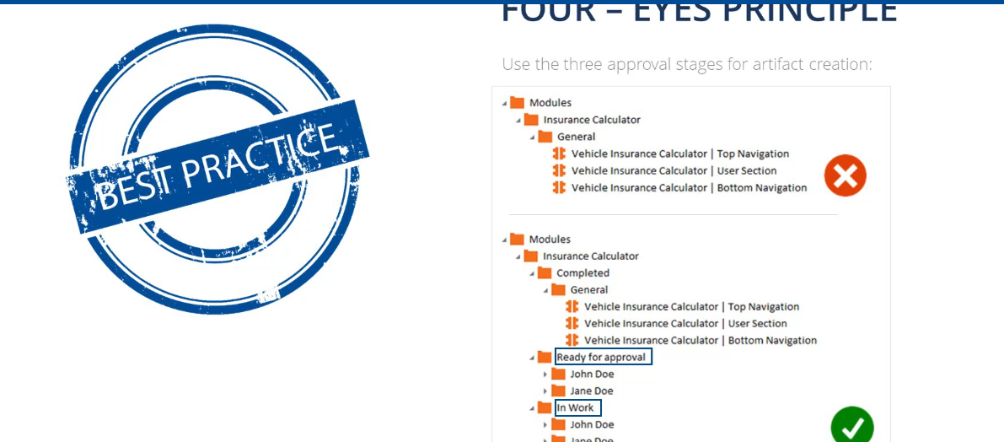

**By doing so what we gain ---Easier maintenance, Greater efficiency and Higher readability in Agile or water fall model but in differs company to company and project to project.**

**Lesson 4:**

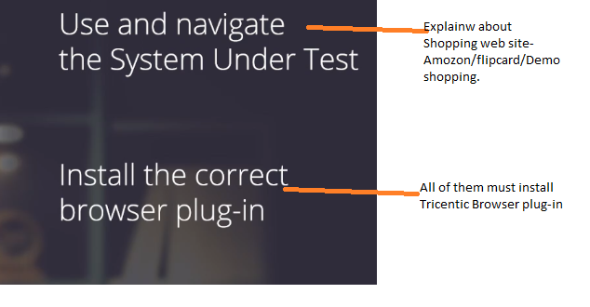

**SECTION-2:**

**Lesson-5:**

**Tosca uses Model -Bases Test Automation instead of Scipt Based Automation.**

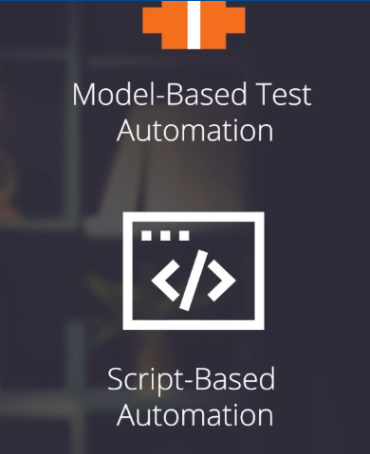

**But Model-Based Test Automation ---Explain in Detail using below images**

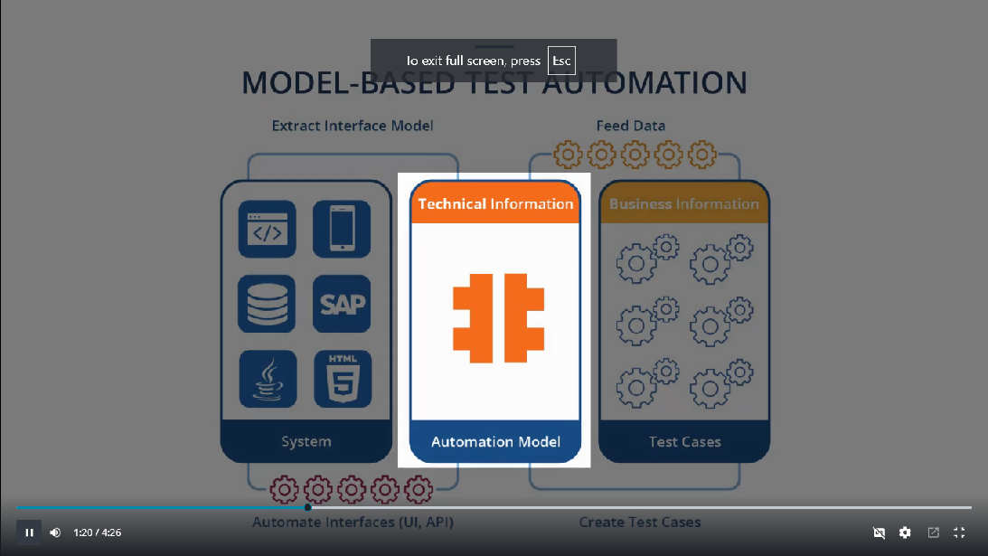

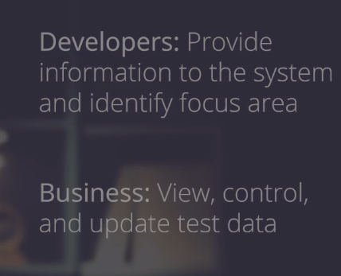

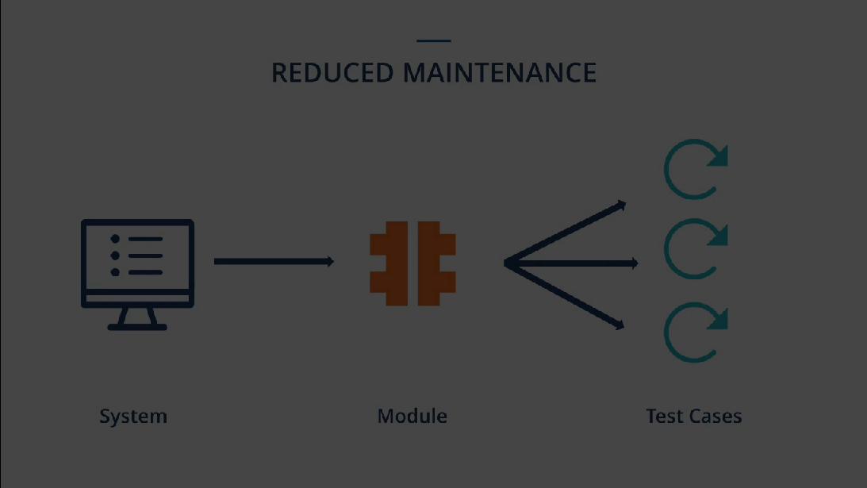

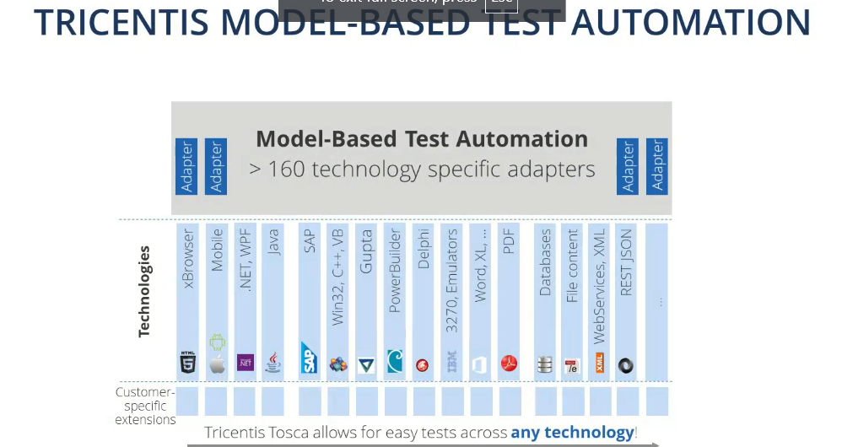

**Example this site can be easily Automated including UI as well as there API's**

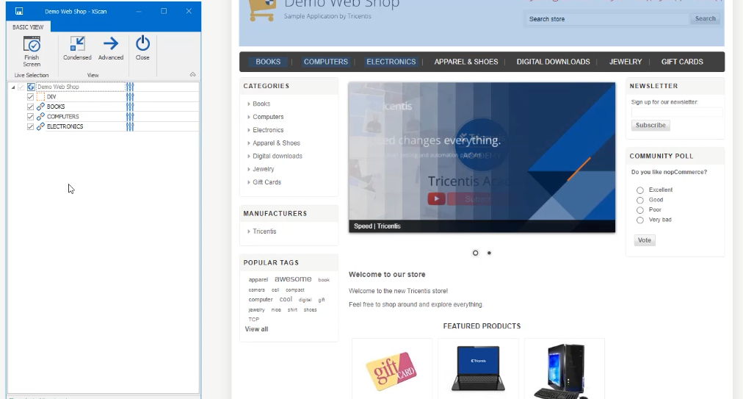

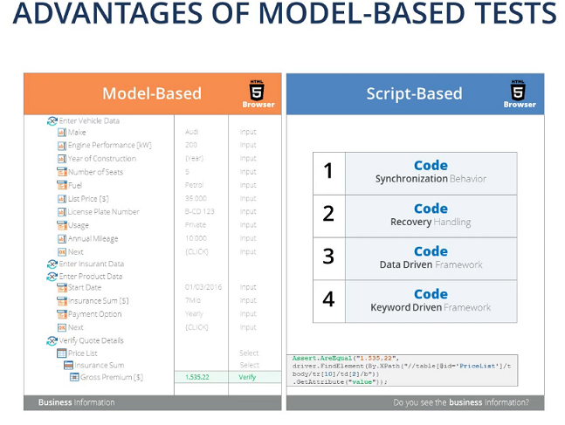

**TOSCA is Applicable to all Technologies like HTML, JAVA, .NET etc.**

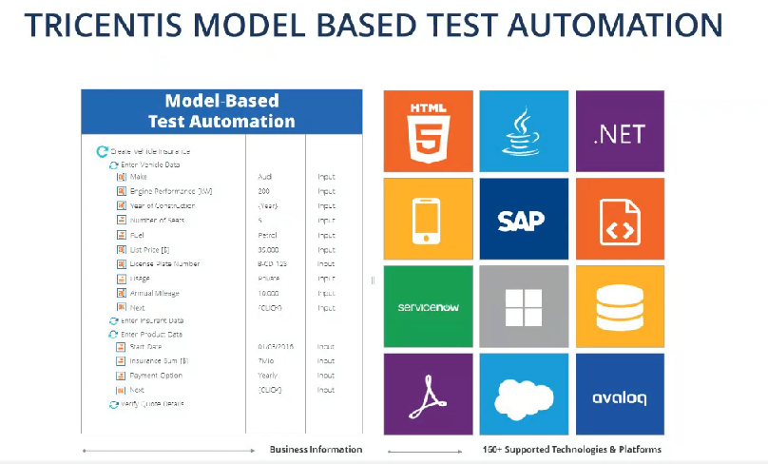

**Hence using Model-Based Test Automation --We can TestApplication Effectively and Efficiently.**

**Lesson 6:**

**Explain about Standard Modules in TOSCA and how to Use them: Windows Operations, Process operations and SAP and other Specialization modules.**

**Standard modules: Explain**

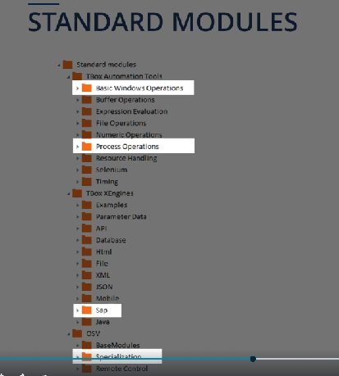

**As TOSCA come up with more technical information as by adding Description column and show:**

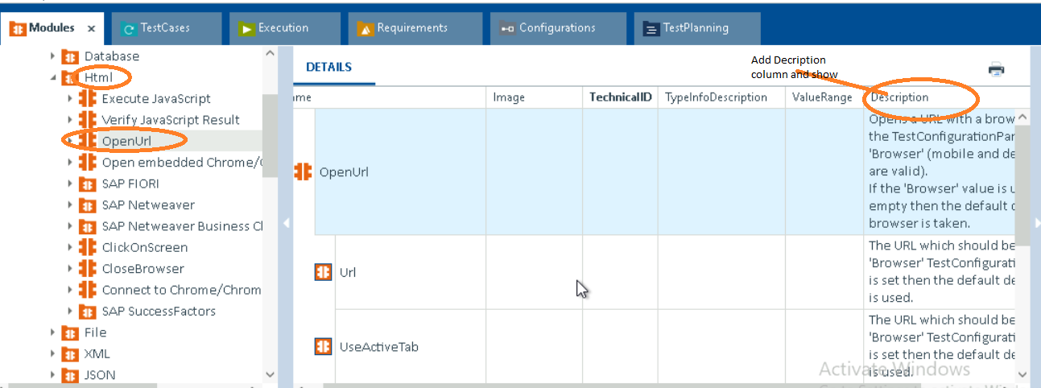

**Show them how to drag and place it in Testcase (As you can drag anywhere you want):**

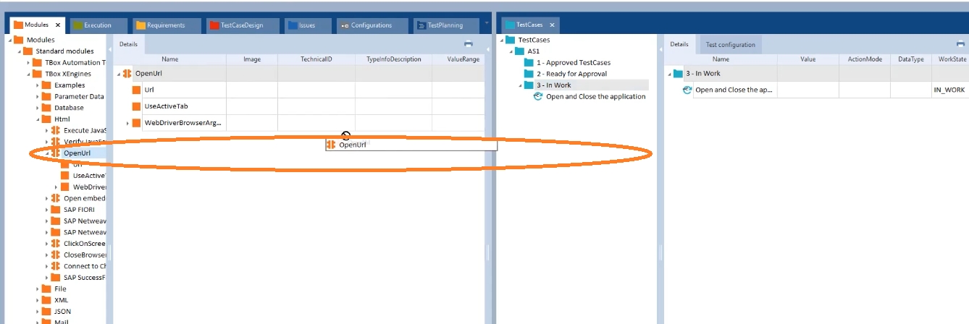

**Best Practice:**

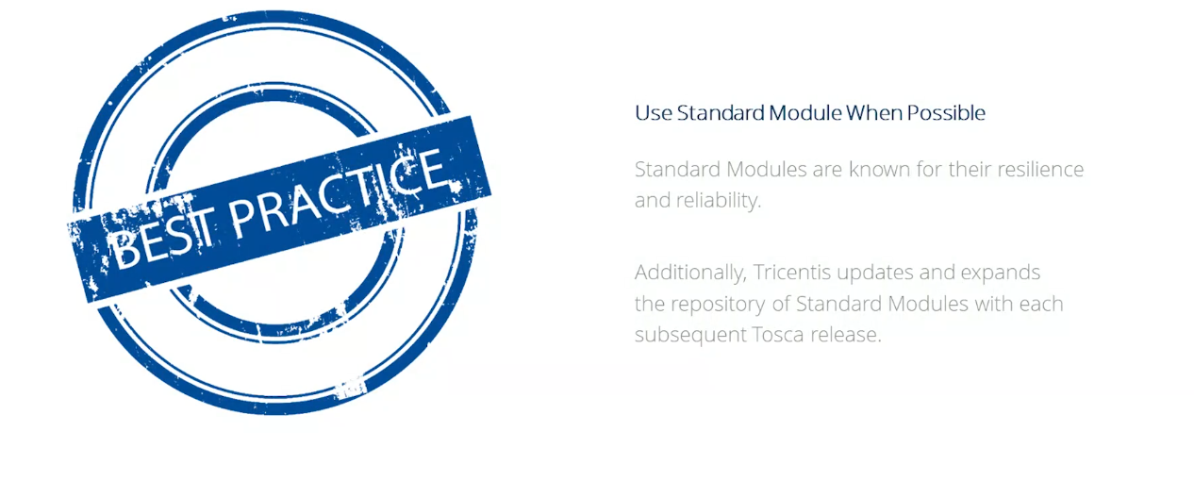

**Lesson 7, 8, 9 &10:**

**Xscan:**

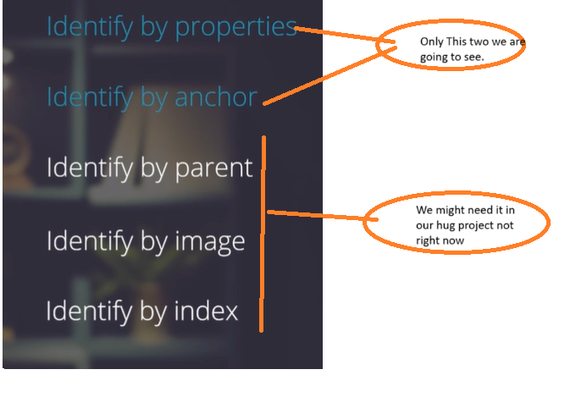

**In XScan we will see the below:**

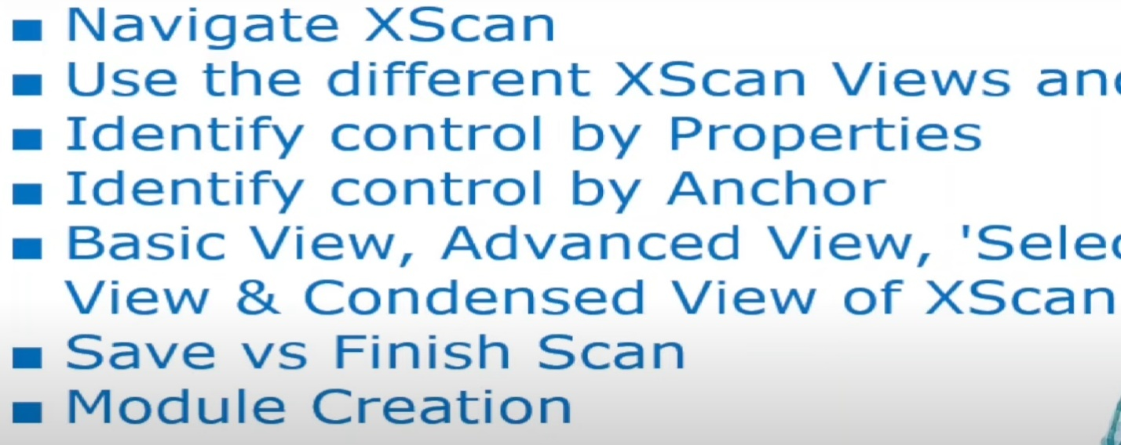

**From the Above full sentence: Use the different XScan views and Buttons**

**Basic view, Advanced View, ‘Selection on Screen’ view option and Condensed view of Xscan.**

**Now explain it in the project.**

**Now right click module Section🡪Scan🡪Application**

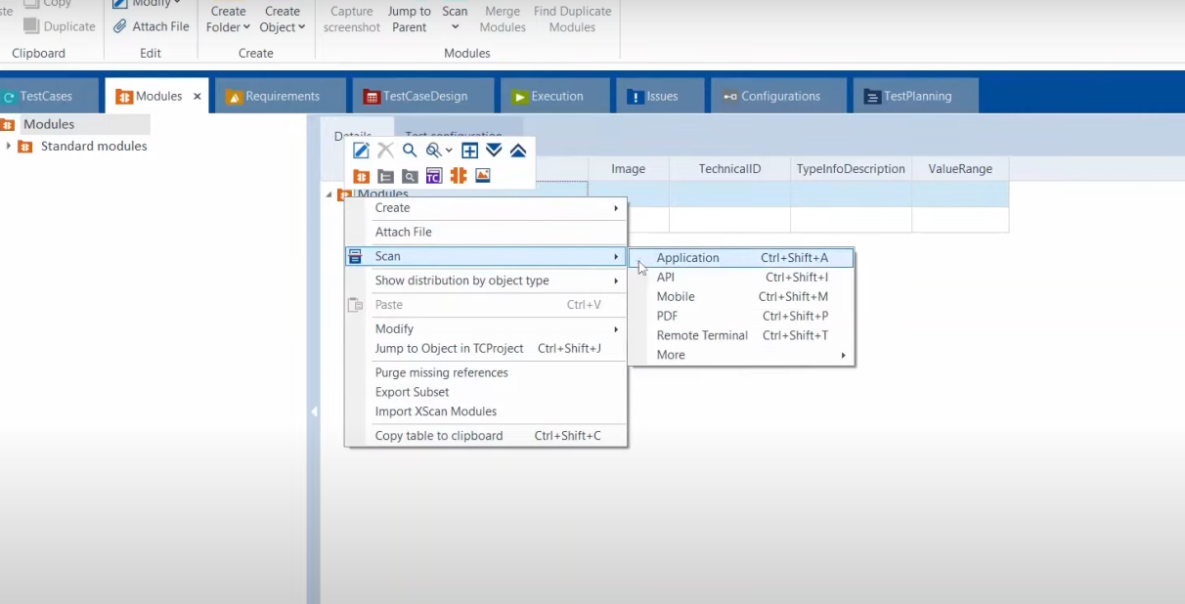

**Generally, I will show all the application in your system, then select the one which you want say—Demo workshop and click on scan**

**We get this” Basic view of xscan” and start selecting it and save so that we can see it in our project**

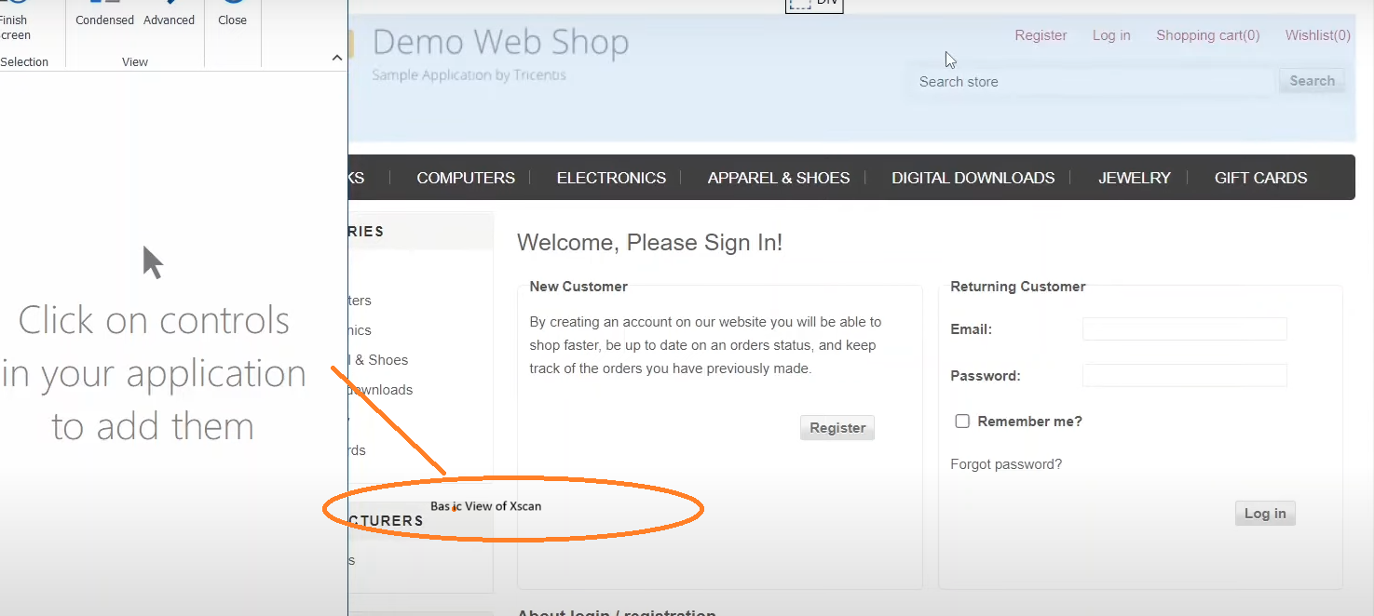

**Advance View—select Select on Screen and add some more button. Once done again we need to select on screen in order to deselect it.**

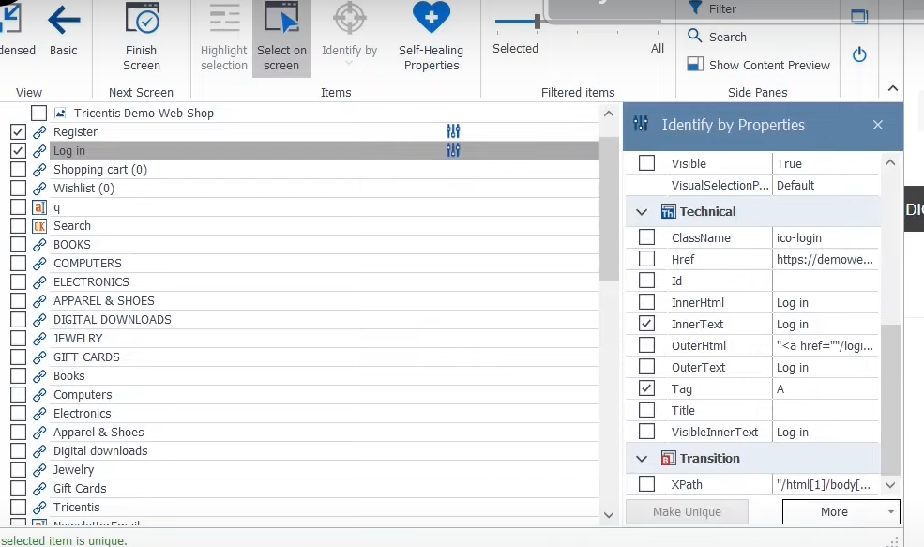

**Condensed View: Explain how task is done and Right side Basic and Finish –Tell them.**

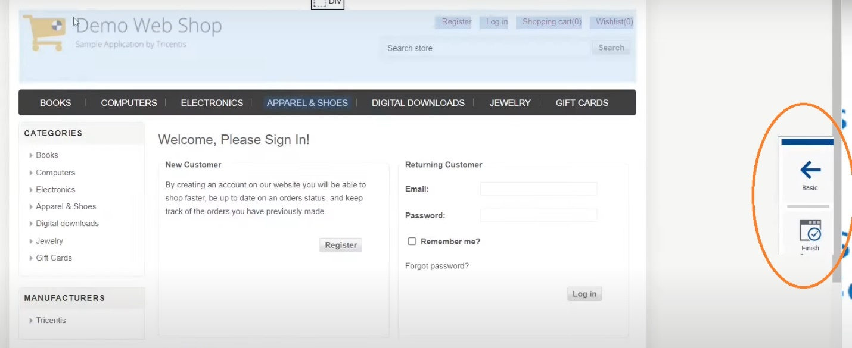

**Note: Explain—once done difference between “Save”/”Finished Screen”/”Highlight”-select and reselect/”Rescan”—Explained below etc. in Detail.**

**\*Very important---structure Explain**

**1) Once module section is done**

**2) Go to Test case:**

**Create Folder (Login Demo-Right click 1st one),Testcase(Login Testcase—Right click 4th one)then Lastly Test steps(Demo Web shop)**

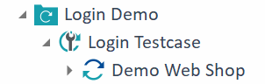

**3) Drag the module which you have created in to Test case and see it is under Test Step(Log in)**

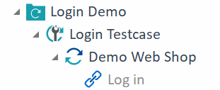

**Then Enter Value—x/Click and Action mode-Input and Data Type-String and save**

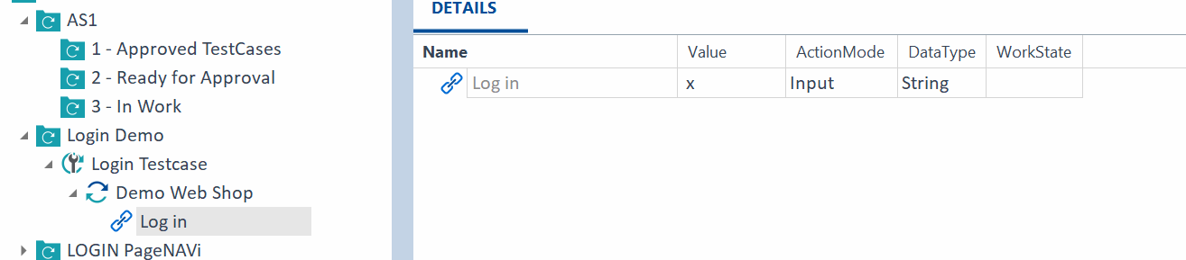

**Now right click on In Testcase window select folder 🡪 Run in Scratch Book.**

**And view the results pass/fail and down Elapsed time N Remaining Time also –Explain.**

**Rescan on the same page or new window can be done by Right clicking on module Rescan.**

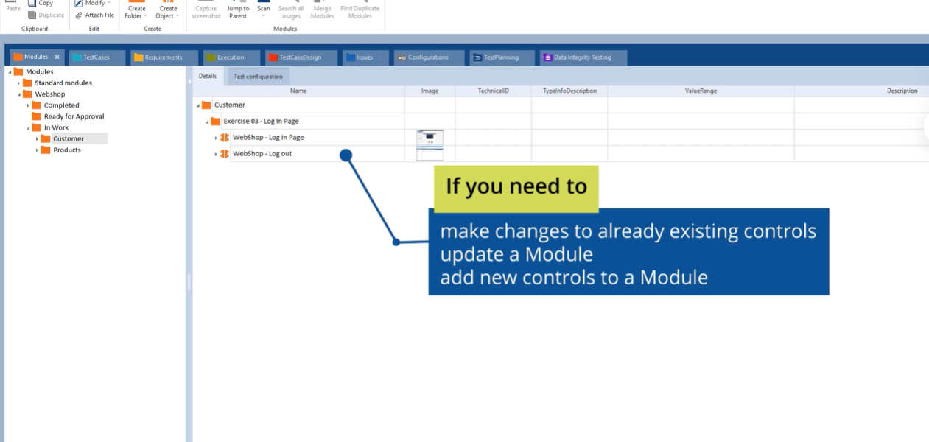

**Same window adding few more fields:**

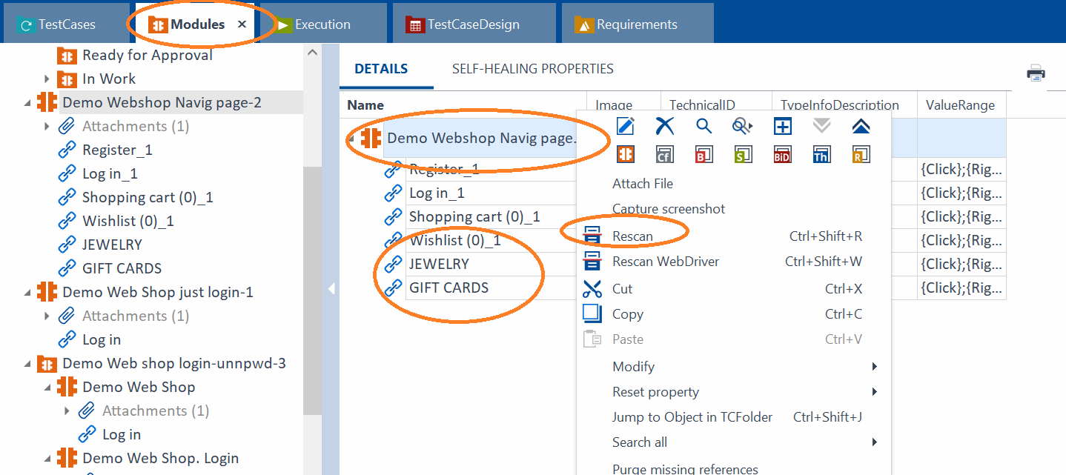

**Different window Rescan after login:**

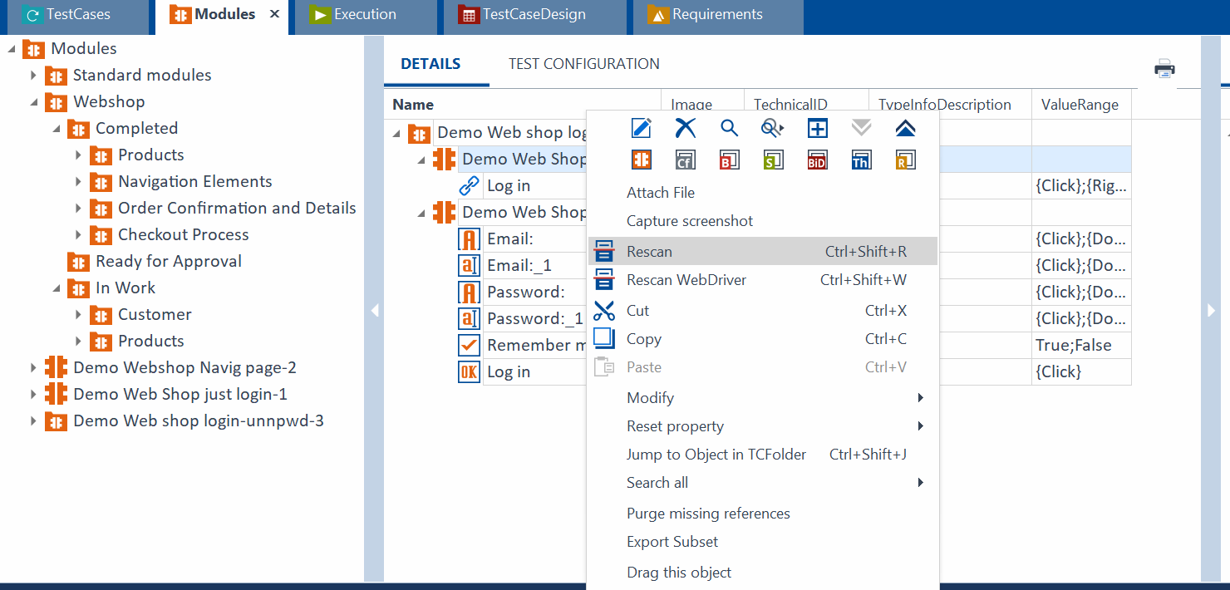

**Once done we need to Drag it to Test case as below for both above and Run in Scratch Book:**

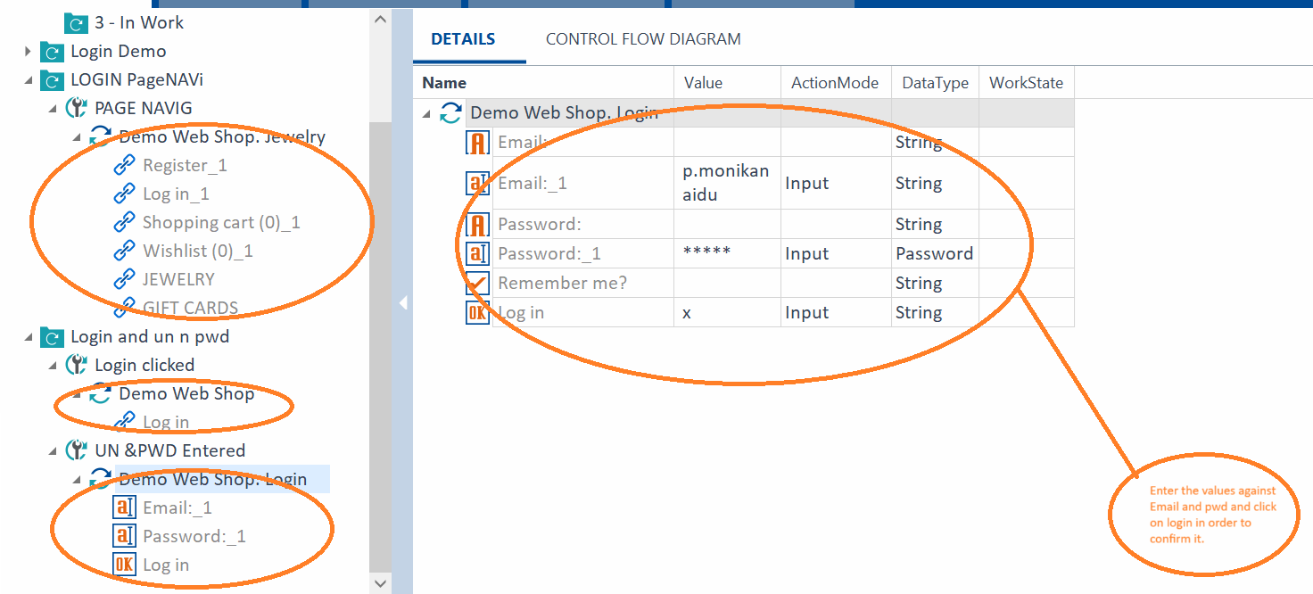

**Xscan—Settings we have these two options--Explain**

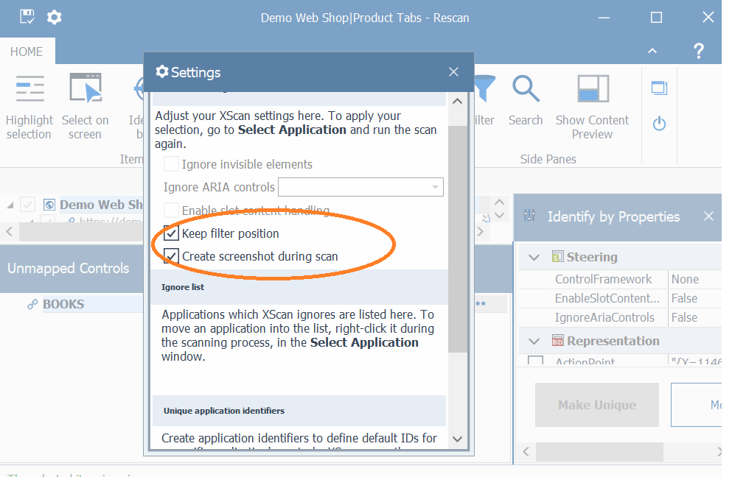

**Identify Controls by Anchor in XScan:**

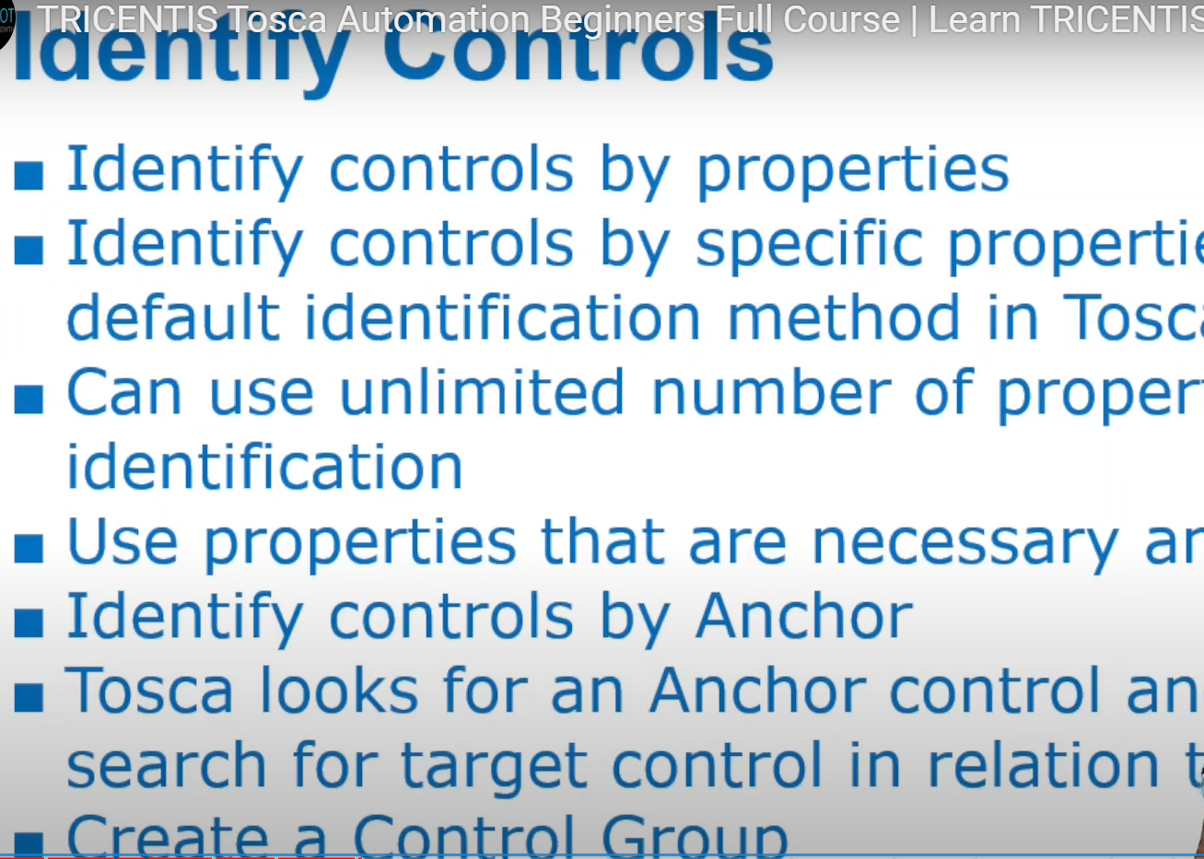

**Explain about Tile property to make it unique say * and here I change in name to “Demo Web Shop” and add properties by tick mark also Explain.**

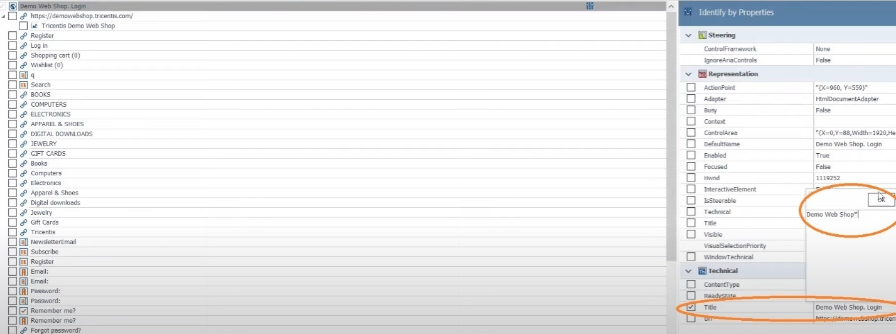

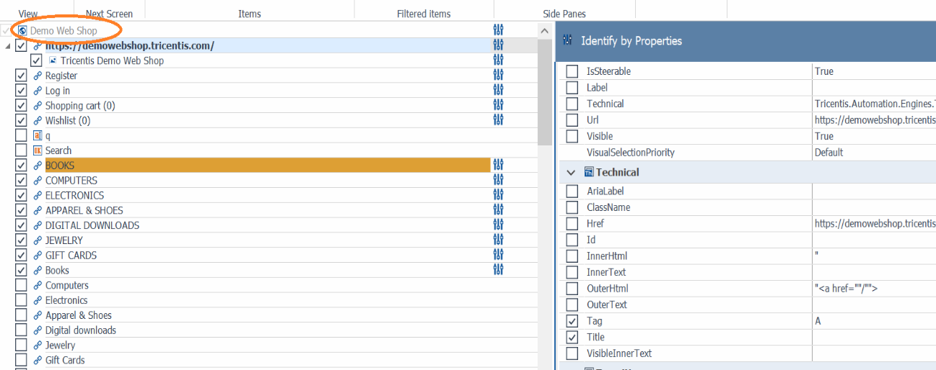

**In Scan-🡪Identify by🡪Anchor select and Drag and drop and select Relative Algorithm—Auto and explain about other options too and Selected ----ALL also drag and explain.**

**Note: It is not must in each and every project we need to use Anchor Explain.**

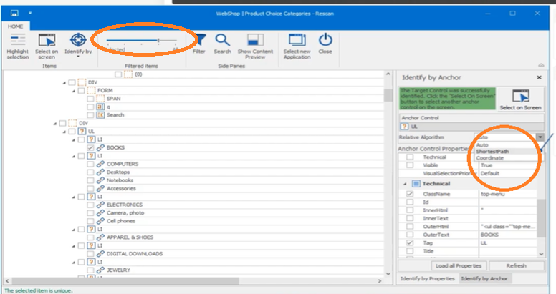

**Once Anchor is selected you can see like this:**